Docker installation and configuration on Windows 10 for a Python web-app.

1. Docker Installation on Windows.

Please follow the below steps for Docker installation on Windows.

<https://docs.docker.com/desktop/windows/install/>

Ensure if Docket has been successfully installed and configured on your machine by following given commands in above URL.

1. After Docket installed successfully. Do below changes on existing SS-Assignment project uploaded on GitHub.
2. Configure the SSAssignment project on IntelliJ or any other Python compatible IDE.
3. Once project gets successfully compiled and you are able to run the main.py file by right click and run main.py command.

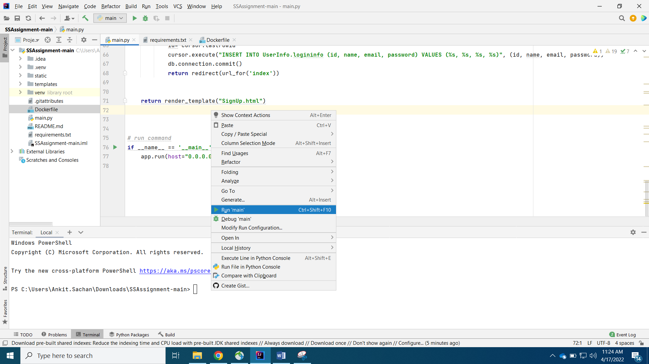

1. Application should be running on given port. 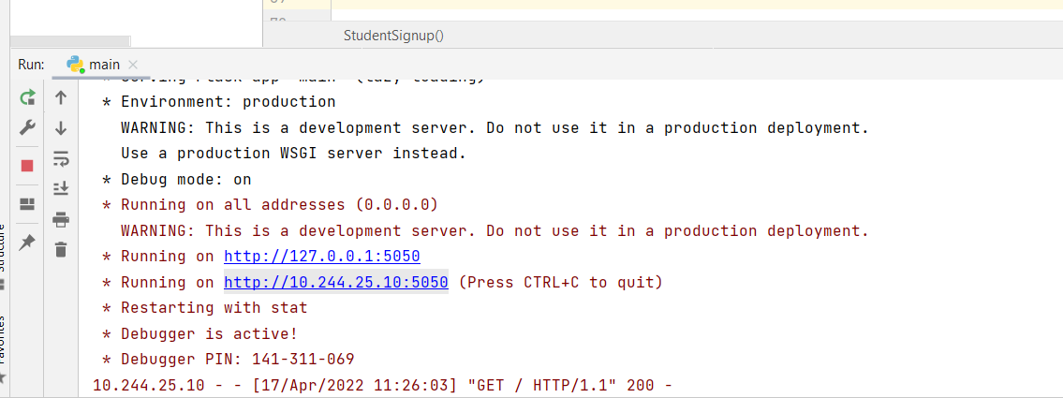
2. Docker Configuration for Python Project.
3. Create a new Dockerfile at the same level of where we have main.py file.

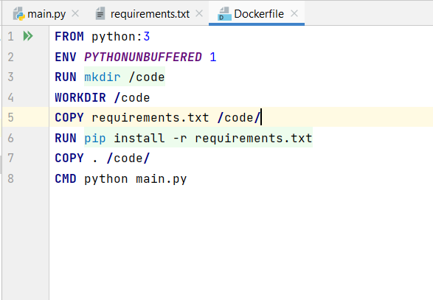

1. Modify the main.py file with latest code available in GIT.
2. Run Docker command to build new image.



There is . at last of command to denote as current directory.

This command will build an image of your project.

1. Run the image inside a container.

Docker run –p 5000:5000 image_name

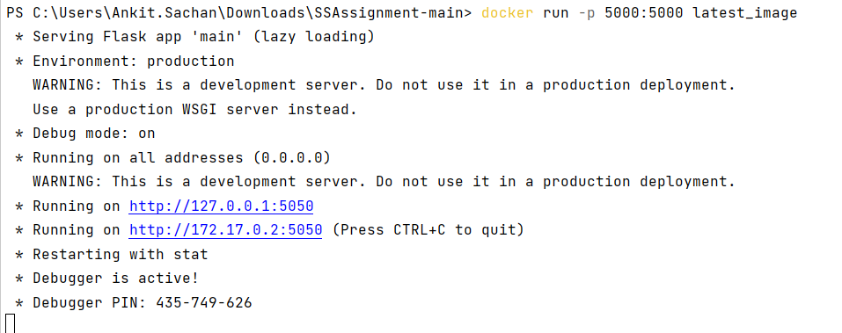

Reference <https://docs.docker.com/language/python/>